


INSTALLATION AND OPERATING MANUAL
Quick Closing Valve Pneumatic Control System
KURTEK Figure No: KTK-1001

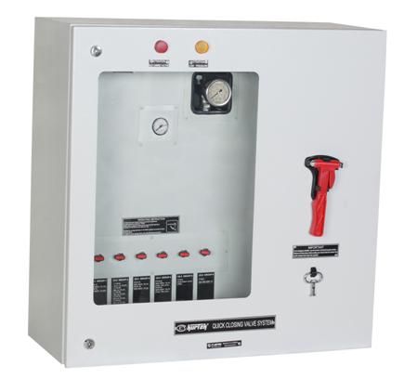

www.kurtekcontrols.com
www.kurtek.com.tr

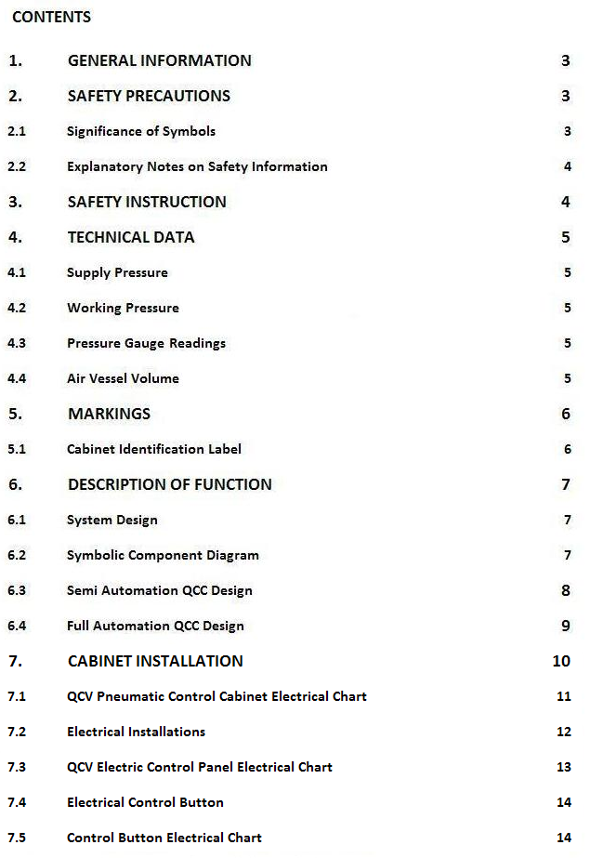

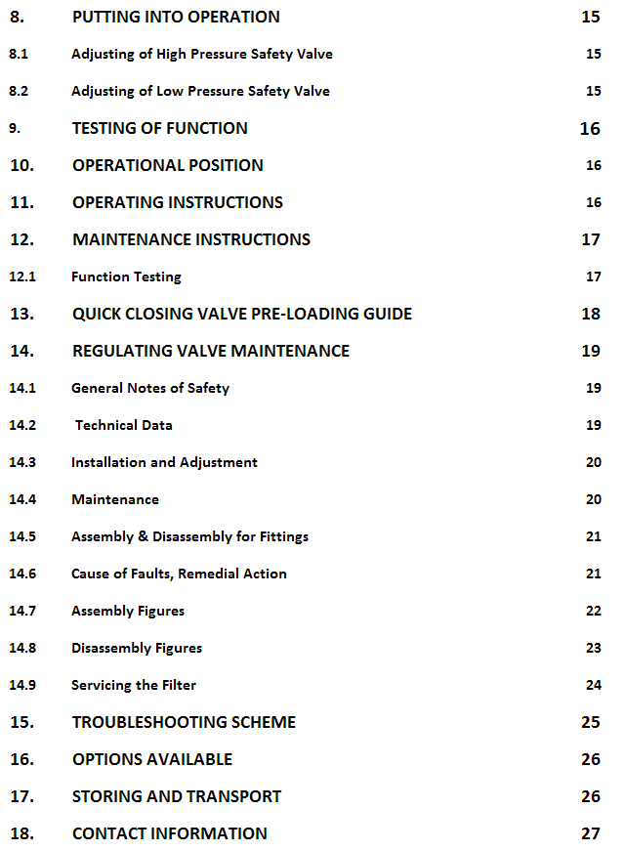

- GENERAL INFORMATION

This manual contains instructions on the use, installation and maintenance of the Pneumatic Control Cabinet; please read carefully before installation.
It is the installer's responsibility to ensure that the Pneumatic Control Cabinet performs satisfactorily, that approved materials are used and that the installation complies with applicable rules and regulations.
As with both installation and maintenance, regional safety requirements must be observed and followed in repair work.
It is the responsibility of the installer and / or ship owners to define the responsibility and competence of personnel for the installation and maintenance of the Quick Closing System.
If problems cannot be solved by referring to the information in this manual, the product supplier will be consulted.
The warnings and notes in the following chapters should be read and followed carefully as they are important to your safety.

Note! The part numbering in sections 6.3 and 6.4 must be retained by the relevant personnel and / or ship owner, as they will be used in all sections for reference.

The manufacturer reserves the right to make technical changes to the product at any time.

- SAFETY PRECAUTIONS

2.1 Significance of Symbols

Attention!

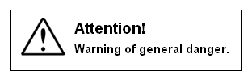

2.2 Explanatory Notes on Safety Information

In this manual dangers, risks, and safety information are highlighted that must be observed.
Information marked with the above symbol and "ATTENTION!" describes the things which can result in serious injury or danger of death for users and/or second parties also what can material damage to the system or the environment.
Compliance and apply with these guidelines is vital.
All other information not specifically emphasized such as transport, installation, operating and maintenance instructions as well as technical data (in the operating instructions, product documentation and on the device itself) must also be complied with to the fullest extent in order to avoid faults, otherwise you can cause serious injury to persons or damage to property.

3. SAFETY INSTRUCTIONS

- Be aware of the fact that the trim of the Quick Closing Valve will fall down very rapidly by spring force while closing of the valve by Pneumatic Control Cabinet; be secure yourselves from the hand wheel and the other moving parts while operation.
- Before working on the Quick Closing System or Quick Closing Valve, notify someone responsible and / or knowledgeable about the System and secure the Pneumatic Cabinet to not operate the system.
- While testing the Quick Closing System, stay away from moving parts of the valve.
- In an emergency, after breaking the cabinet glass, clean all sharp pieces of glass before putting your hands inside the cabinet.
- Always vent the air pressure before overhaul or dismantling of any part.
- Loosening any part under system pressure can cause injury.

4. TECHNICAL DATA

4.1 Supply Pressure

The design and lay-out of the system is to be taken from enclosed data sheet and symbolic diagram.
The symbolic diagram shows the stipulated air supply pressure.
Most cabinets have the air supply from the 30 bar engine starting air system.
Safety valve with standard set point 32 bar is mounted on the air vessel connection block.

4.2 Working Pressure

Pneumatic Cabinet is equipped with 30 bar air supply tank; but while air shot that sending to the valve, will decrease the pressure from 30 bar to 8bar by the pressure reducing valve which mounted on the main supply line
A safety valve with a set point of 8.8 bar is installed on the operating pressure side of the system (before Quick Closing Main Supply Line).
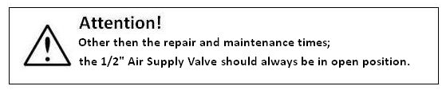

4.3 Pressure Gauge Readings

Pressure gauge showing supply pressure is located on the connection block for the air vessel.
Pressure gauge showing reduced air pressure is fitted directly to the pressure regulator.

4.4 Pressure Vessel Volume

The required Pressure vessel volume is achieved with a single pressure vessel.
The calculation of the required pressure vessel volume is based on the number of valves installed, the total volume of pipes between the cabinet and valve actuators, and the stroke volume of the actuators.
The air supply pressure is the main factor in calculating the required volume.
As a safety factor, it is mandatory for most classification societies to be able to close all Quick Closing Valves at least twice in one charge of the pressure vessel.

5. MARKINGS

Each cabinet has a serial number label inside; Classification marks of the cabinet and the identifications of the pressure vessel are located on the pressure vessels' shell.

5.1 Cabinet Identification Label

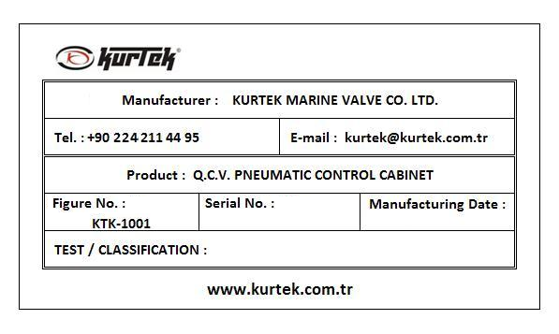

5.2 Cabinet Location

In case of fire, the cabinet should be placed in a safe area where the flames will reach last, and easily accessible for the immediate closure of the valves.

6. DESCRIPTION OF FUNCTION

6.1 System Design

The control cabinet contains necessary armature for storing, reducing and directing the air flow to the actuators on the quick closing valves.
The pressure of the air flow from the control cabinet is filled into the trigger on the valve and pulls the trigger pin from the path of the valve assembly, allowing the valve disc to fall at high speed and close the liquid flow path by the force of the valve.
Each discharge valve of cabinet can control a single valve or a set of valves.
The system designer is responsible for the efficient operation of the actuator after the design of the control system and the grouping of the valves.

6.2 Symbolic Component Diagram

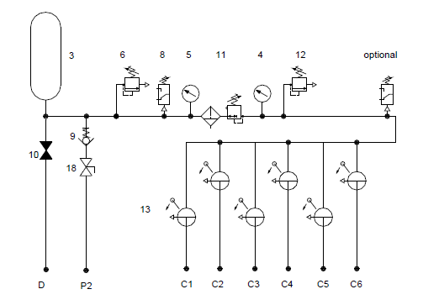

6.3 Semi Automation QCC Design
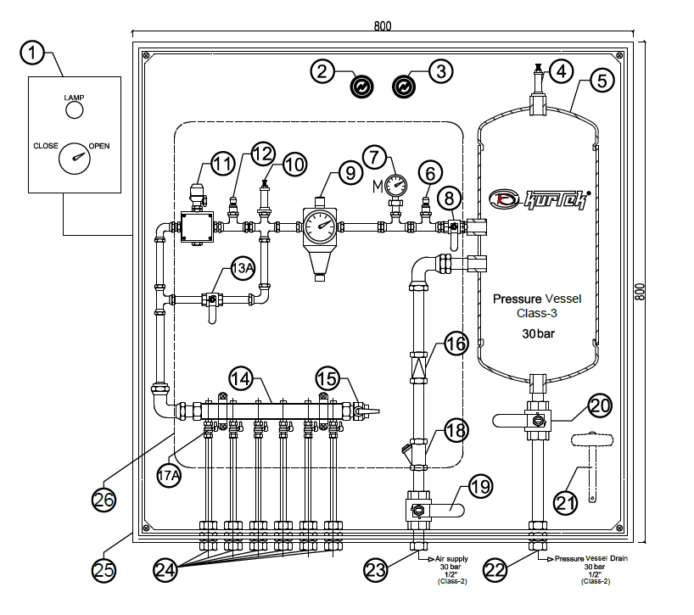
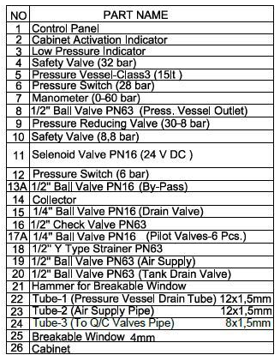

6.4 Full Automation QCC Design

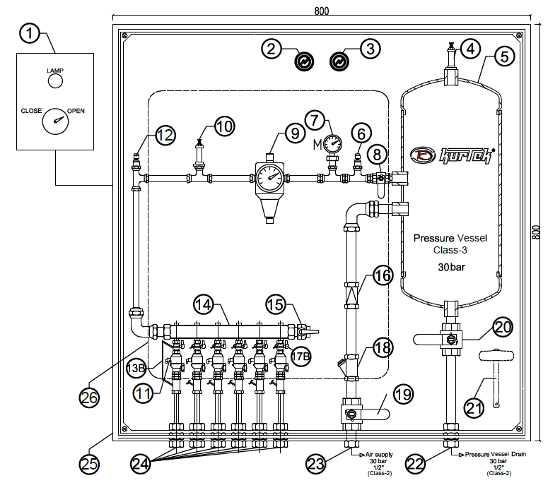
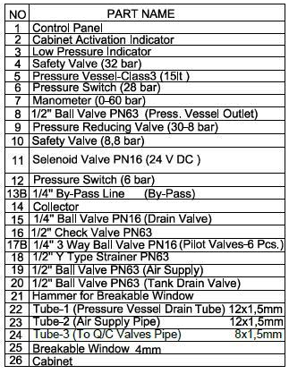

7. CABINET INSTALLATION

The cabin should be mounted in the vertical position to the ship's board or to a strong place that will be least affected by the vibration of the ship through the screw holes in the rear part.
We recommend installing the cabinet using the vibration dampers included in the package.

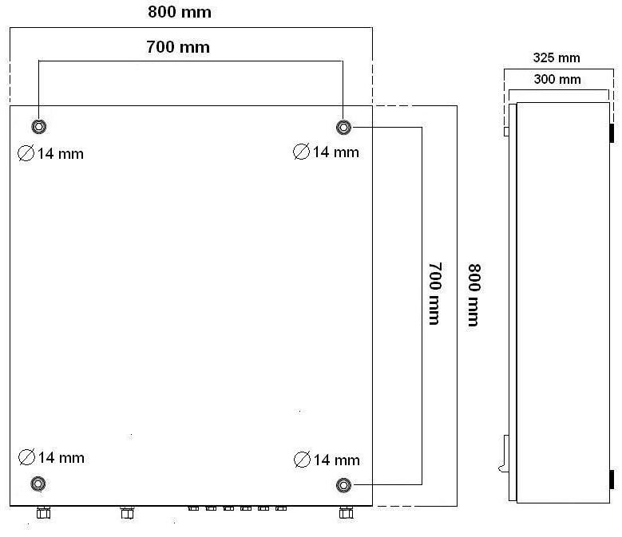

Note! The cabinet is seen from backside.

The pipes are connected to each valve group or single valve according to the pipe system preferred by the designer in the design.
Select the pipe type according to the rules of the classification communities and the area you are in. When the pipes are cut and formed, they must be cleaned in such a way that no particles, burrs and dirt remain in them. The pipeline should be pulled in such a way as to prevent condensation, considering the possibility of condensation.

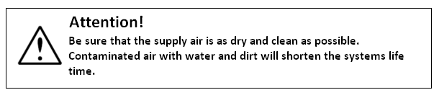

7.1 QCV Pneumatic Control Cabinet Electrical Chart
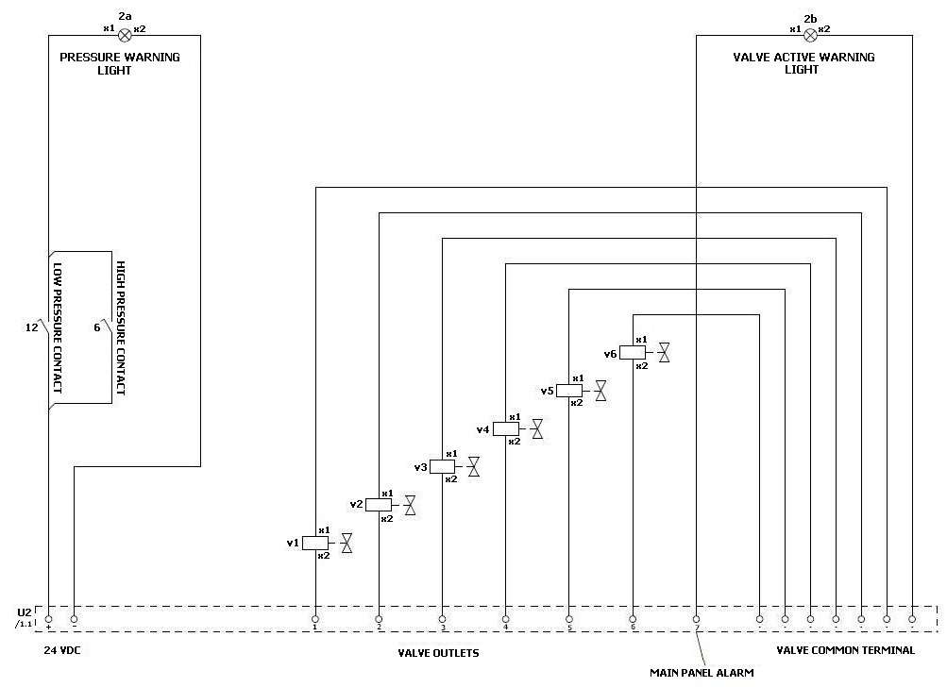

Note! Turn the page clockwise to view from the right angle

7.2 Electrical Installations

The pressure switch or pressure switches are electrically connected directly to the DIN connection on the switches. For connection figures; see the label on the pressure switch or following product description included.
Cable installations for "Valve Position Indicating System" shall follow from the separate drawings coming with the unit.
Electric Control Panel installation is as following.

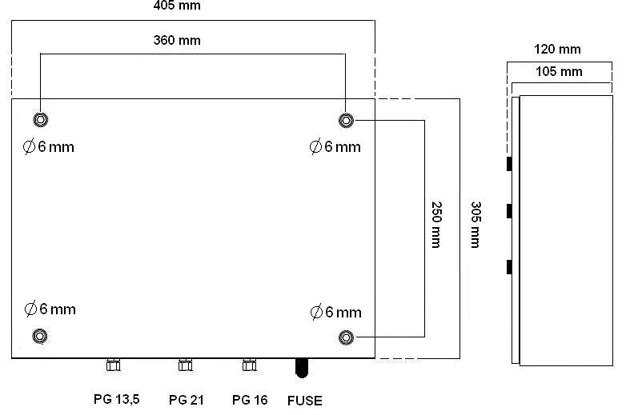

Note! The cabinet is seen from backside.

7.3 QCV Electric Control Panel Electrical Chart

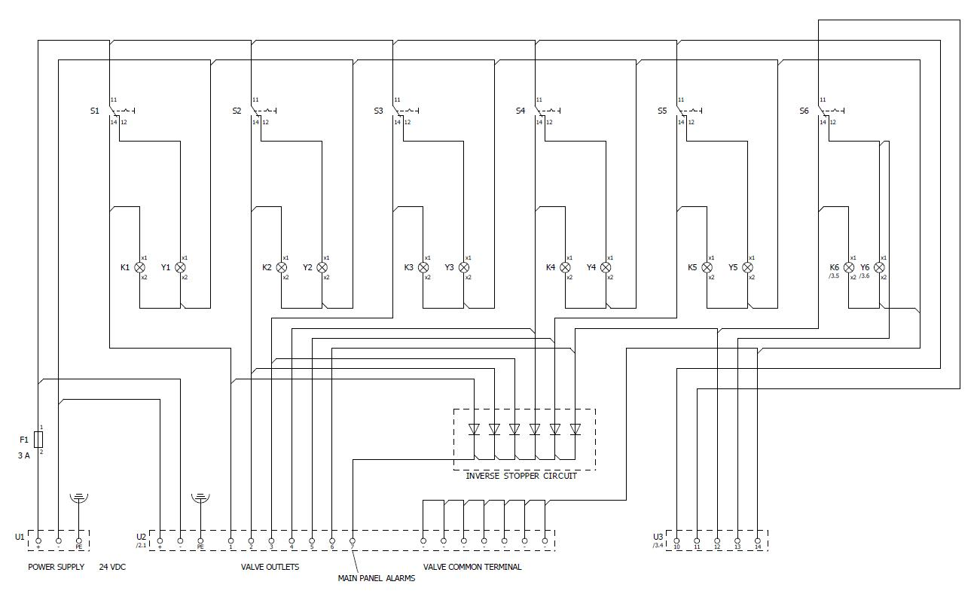
Note! Turn the page clockwise to view from the right angle

7.4 Electrical Control Button

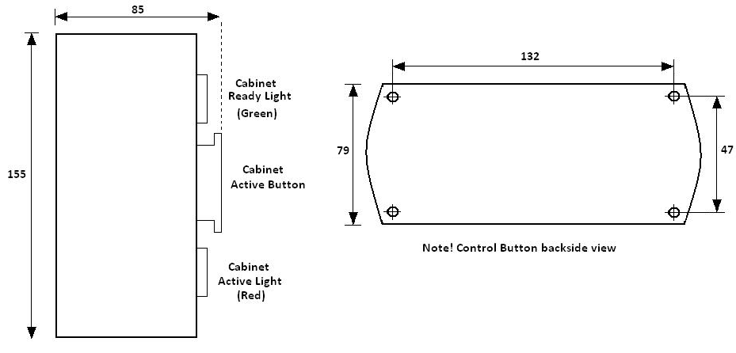

7.5 Control Button Electrical Chart

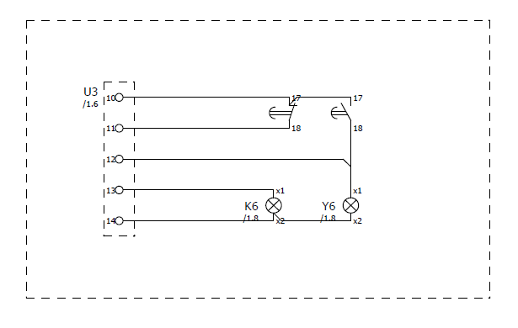

8. PUTTING INTO OPERATION

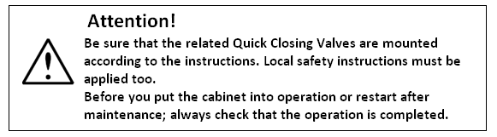

8.1 Adjusting of High Pressure Safety Valve

The high pressure safety valve is adjusted at the factory before delivery.

8.2 Adjusting of Low Pressure Safety Valve

The low pressure safety valve is adjusted at the factory before delivery.

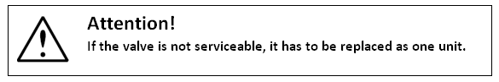

9. TESTING OF FUNCTION

- Charge the air vessel with air.
- Put all control handles in closed position (quick closing valves will then close).
- Close the air charging valve in air supply line.
- Check piping system for leakage.
- Put the control valves into open position.
- Reset the quick closing valves to open position. This is done by using the hand wheel on top of the quick closing valve. See quick closing valve Installation and Maintenance manual.
- Open the air supply valve and charge the air vessel full.
- Close the air supply valve.
- Operate each control handle and check that corresponding quick closing valve or valves will close.
- Repeat the operation without charging the air vessel. Check that all valves will close also after the second operation.

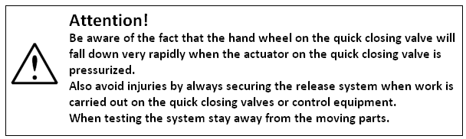

10. OPERATIONAL POSITION

- Put the control handles in open position
- Open and load the quick closing valves
- Secure the air supply valve in open position.
- Check pressure gauge readings.
- Close the door.

11. OPERATING INSTRUCTIONS

In an emergency, follow the instructions on the outside of the cab and open the door using the key; For cabinets without key and / or id the key is missing, break the glass using the emergency bat. Before operating the control cabinet, remove any sharp glass particles;
Pull the handle fully down for turn the valves to closed position.

12. MAINTENANCE INSTRUCTIONS

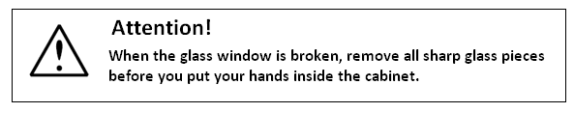
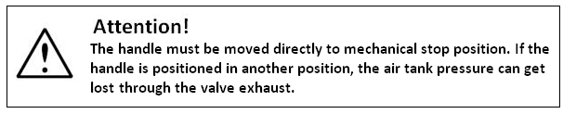

12.1 Function Testing

At regular intervals and/or at a classification survey check the function of the system.

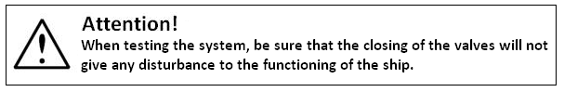

13. QUICK CLOSING VALVE PRE-LOADING GUIDE

To get KURTEK Quick Closing Valve in operational position;
- Before pre-loading block no.1 is at level B.
- Turn the hand wheel clockwise.
- Block no.1 will move upwards and when it passes the shaft of cylinder no.2.
- The shaft will move outwards automatically and latches block no.1 in position.
- Rotate the hand wheel counter clockwise, the valve will turn to open position.
- Your Quick Closing Valve is now ready for operation.
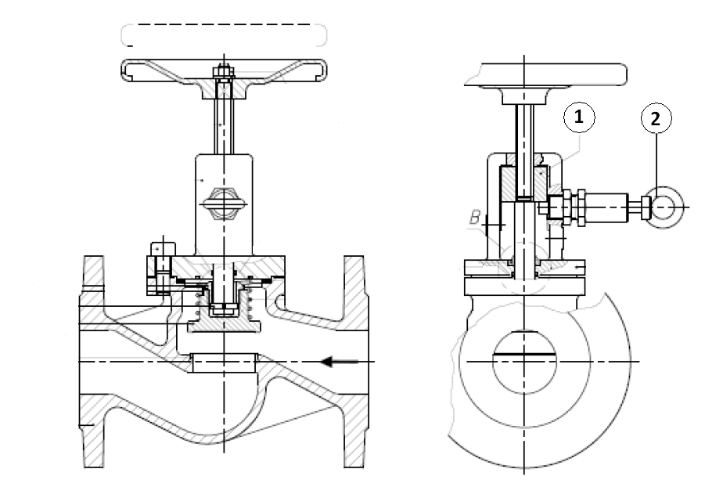

14. REGULATING VALVE MAINTENANCE

14.1 General Notes of Safety
- Only use the valve:
- For the intended purpose
- In satisfactory condition
- With respect for safety and potential hazards
- Use only for gases compatible with the materials used.
- Always observe the installation instructions.
To ensure correct use; always make sure to only install pressure reducer in places where the operating pressure and temperature do not exceed the design criteria on which the order is based. The manufacturer shall not be responsible for damage caused by outside forces or other external influences! Hazards at the pressure reducer caused by the flow medium and operating pressure are to be avoided through appropriate measures.
- All assembly work is to be carried out by authorized specialist staff.

14.2 Technical Data

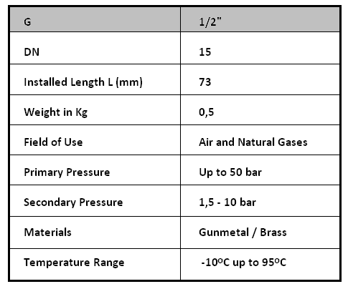

14.3 Installation and Adjustment

The flow direction must coincide with the arrow on the housing.
The valve can be installed in any mounting position.
The pipe must be thoroughly flushed prior to installation of the pressure reducer to prevent impurities picked up by the medium having an impact on the satisfactory operation.

Attention!! Before commissioning the pressure reducer, make sure that the manometers are connected to the two manometer connections on the housing or that they are closed with a sealing plug.
The desired secondary pressure is set by turning the adjusting spindle at idle pressure (zero consumption).
Turning the adjusting spindle in clockwise direction increases the secondary pressure and turning the spindle in counter-clockwise direction reduces the secondary pressure. When choosing the setting, check that the secondary pressure, set for zero consumption; reduces during operation depending on the volume removed. The set desired value can be checked at the pressure gauge arranged on the secondary pressure side.

14.4 Maintenance

The device should be checked at intervals which correspond to the respective operating conditions in order to eliminate any faulty operation which may be caused by impurities, scaling and natural wear.
After long periods of non-use the function of the valve must be tested.
Caution!! When carrying out assembly work on the pressure reducer, the corresponding system part must always be relieved of pressure and emptied, depending on the medium used.
At high temperatures you must always wait for the temperature to cool down to ambient temperature.

14.5 Assembly and Disassembly for Fittings

For disassembly refer to figures (a) to (h); for assembly refer to figures (i) to (p). In addition to the general valid assembly instructions, attention must be paid that the installation must be depressurized before dismantling the valve.

14.6 Cause of Faults, Remedial Action

- If the outlet pressure rises above the set value,
The gasket is dirty or the cone seal is leaking.
- Corrective action:
Clean the taper or replace if necessary.

- Pressure If output pressure falls below zero consumption
The gasket is not tightened or the spring cap is insufficiently tightened.
- Corrective action:
Replace the seal or retighten the spring cap.

14.7 Assembly Figures

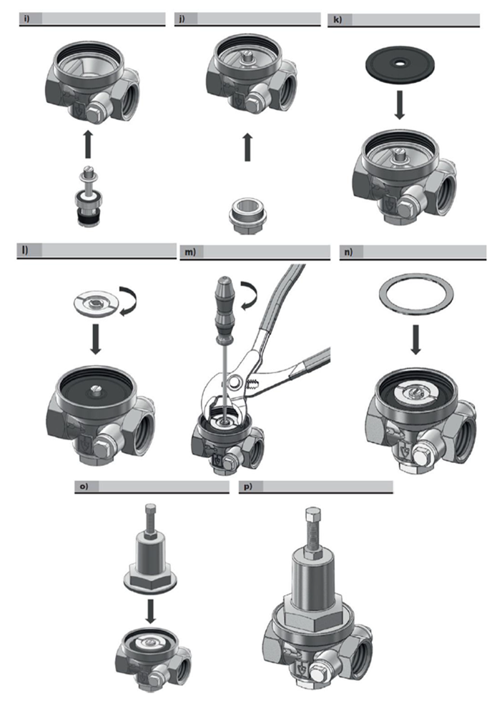

14.8 Disassembly Figures

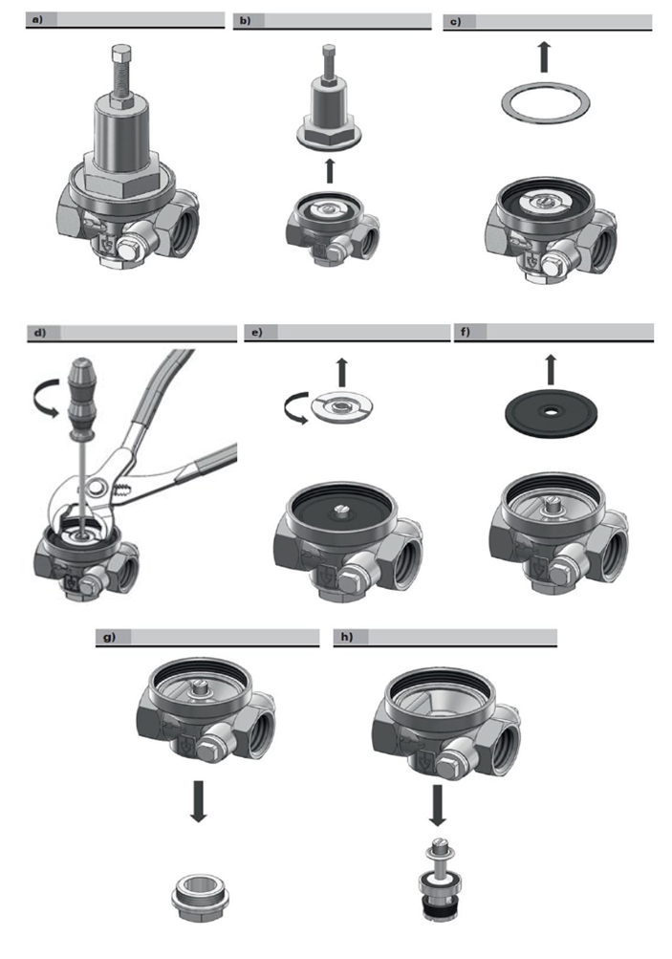

14.9 Servicing the Filter

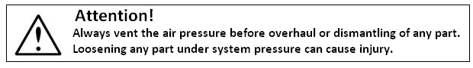

- For manual drain mode, regularly open drain to expel accumulated liquids. Keep liquids below element retainer.
- Since the direction of air flow is from the inside of the element to the outside, a clean exterior is not an indication of freedom for contamination.
- If the element shows evidence of blockage, replace with new element.
- Clean the element retainer, the upper and lower gaskets before replacing the element – avoiding over tightening of the retainer.
- Inspect the bowl O-ring for damage and renew if necessary.
- Clean and replace filter element when dirty.

Note:
Intervals for removing the filter bowl can vary depending on the quality of inlet air and consumption.
This operation can be scheduled after experience when the filter element has been inspected for some time.

15. TROUBLESHOOTING SCHEME
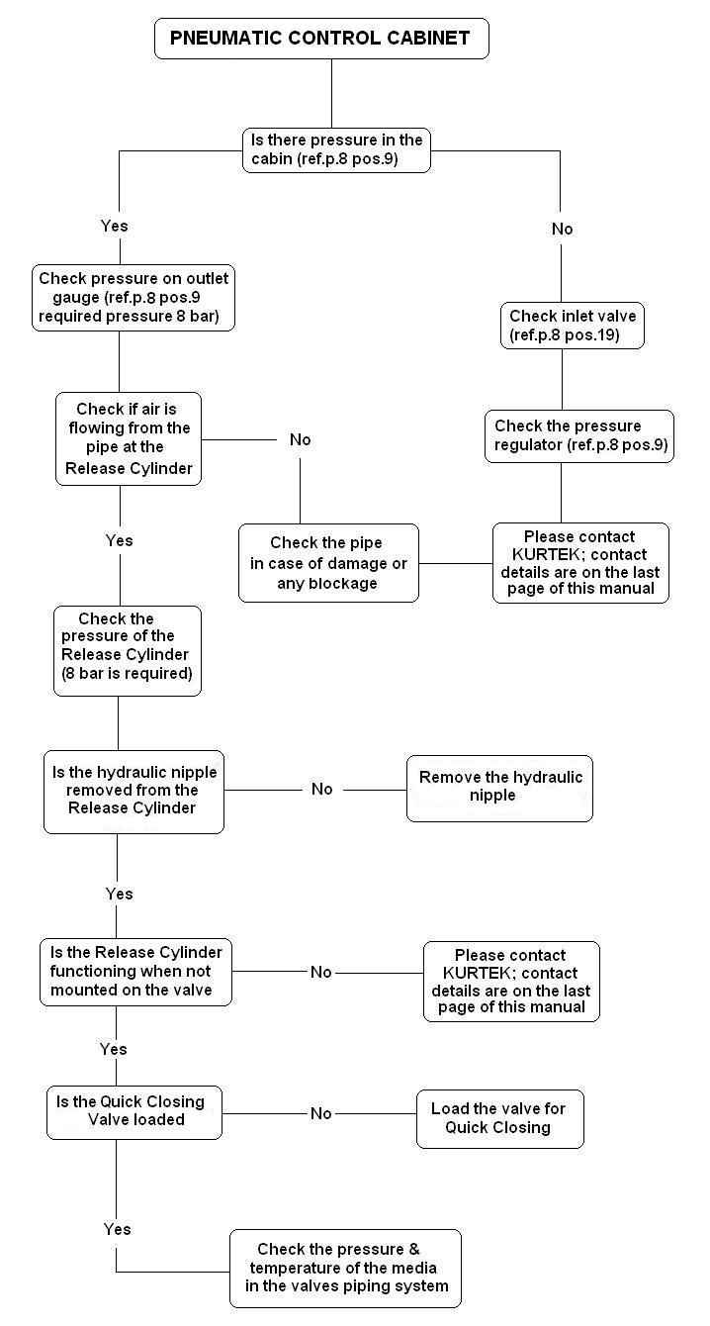

16. OPTIONS AVAILABLE

The standard PCS are available with the following option:
- High / Low pressure warning lights
- QCV Cabinet active warning lights
- Low pressure switch
- Special custom made signboards
- Vibration Insulator for the cabinet fixing

17. STORING AND TRANSPORT

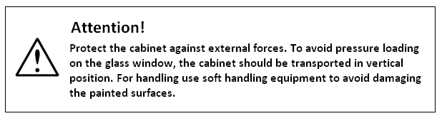

- The cabinet shall be stored indoors well protected from dust and moisture.
- Long time storing must be done in warm warehouses to avoid corrosion attack on unprotected surfaces.
- Plastic protection covers fitted to pipe connection threads are not to be removed until pipe assembly.

18. CONTACT INFORMATION

Your Pneumatic Control Cabinet is designed and manufactured by:

KURTEK GEMI MAKINE SAN. VE TIC. LTD. STI.
Buttim Is Merkezi
B-5 No:1416
Osmangazi 16250
BURSA / TURKEY

Tel.: +90 224 211 44 95
Fax: +90 224 211 04 95

Website: www.kurtekcontrols.com
www.kurtek.com.tr
E-mail: kurtek@kurtek.com.tr

